**CDS Network Process Components**

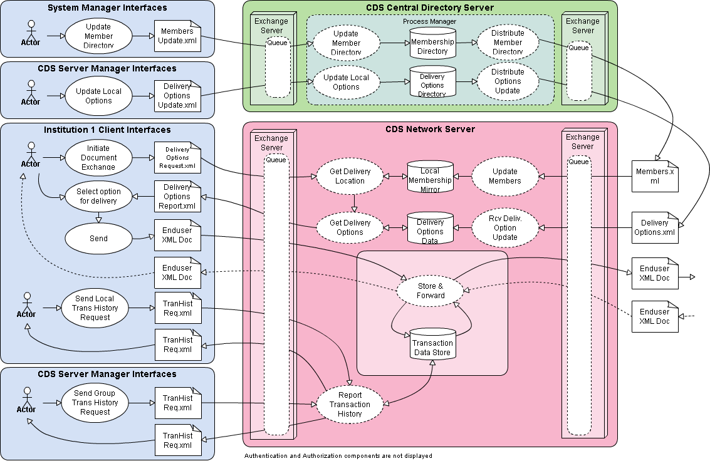

Joseph Giroux – 3/16/2012